Name: | Debjit Ghosal
UID: | 2023300065
Experiment No. | 10B

AIM: | Multithreading
Program 1
PROBLEM STATEMENT : | Write a two-threaded program, where one thread finds all prime numbers (in 0 to 100) and another thread finds all palindrome numbers (in 10 to 1000). Schedule these threads in a sequential manner to get the results. Now reschedule them as parallel threads.
PROGRAM: | /*  Write a java program for two-threaded program, where one thread finds all prime numbers (in 0 to 100) and another thread finds all palindrome numbers (in 10 to 1000). Schedule these threads in a sequential manner to get the results. Now reschedule them as parallel threads.  */  import java.util.Scanner;  import java.util.ArrayList;  import java.util.List;  class PrimeFinder extends Thread {  private List<Integer> primeNumbers = new ArrayList<>();  @Override  public void run() {  for (int i = 0; i <= 100; i++) {  if (isPrime(i)) {  primeNumbers.add(i);  }  }  }  public List<Integer> getPrimeNumbers() {  return primeNumbers;  }  private boolean isPrime(int num) {  if (num <= 1) return false;  for (int i = 2; i <= Math.sqrt(num); i++) {  if (num % i == 0) return false;  }  return true;  }  }  class PalindromeFinder extends Thread {  private List<Integer> palindromeNumbers = new ArrayList<>();  @Override  public void run() {  for (int i = 10; i <= 1000; i++) {  if (isPalindrome(i)) {  palindromeNumbers.add(i);  }  }  }  public List<Integer> getPalindromeNumbers() {  return palindromeNumbers;  }  private boolean isPalindrome(int num) {  int temp = num;  int reverse = 0;  while (temp != 0) {  int digit = temp % 10;  reverse = reverse * 10 + digit;  temp /= 10;  }  return num == reverse;  }  }  public class TwoThread {  public static void main(String[] args) {  // Sequential Execution  PrimeFinder primeFinder = new PrimeFinder();  PalindromeFinder palindromeFinder = new PalindromeFinder();  primeFinder.start();  try {  primeFinder.join();  } catch (InterruptedException e) {  e.printStackTrace();  }  palindromeFinder.start();  try {  palindromeFinder.join();  } catch (InterruptedException e) {  e.printStackTrace();  }  System.out.println("The Sequential Prime Numbers: " + primeFinder.getPrimeNumbers());  System.out.println("The Sequential Palindrome Numbers: " + palindromeFinder.getPalindromeNumbers());  // Parallel Execution  PrimeFinder parallelPrimeFinder = new PrimeFinder();  PalindromeFinder parallelPalindromeFinder = new PalindromeFinder();  parallelPrimeFinder.start();  parallelPalindromeFinder.start();  try {  parallelPrimeFinder.join();  parallelPalindromeFinder.join();  } catch (InterruptedException e) {  e.printStackTrace();  }  }  }
RESULT:
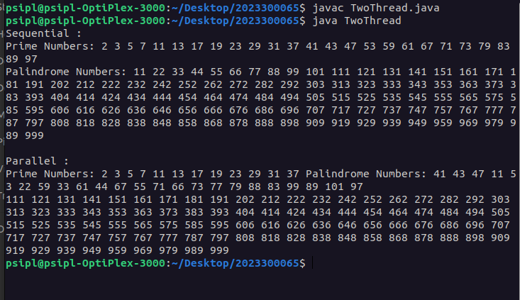

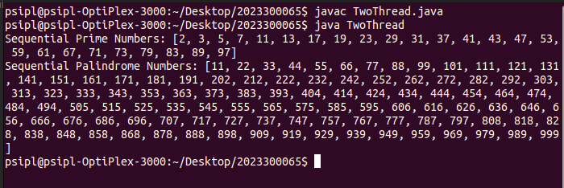
Program 2
PROBLEM STATEMENT : | Write a Java program that implements a multi-thread application that has three threads. First thread generates a random integer for every 1 second; second thread computes the square of the number and prints; third thread will print the value of cube of the number.  Sample Output:  Random Integer generated : 82  Square of 82 = 6724  Cube of 82 = 551368
PROGRAM: | /*  Write a Java program that implements a multi-thread application that has three threads. First thread generates a random integer for every 2 second; second thread computes the square of the number and prints; third thread will print the value of cube of the number.  Sample Output:  Random Integer generated : 82  Square of 82 = 6724  Cube of 82 = 551368  */  import java.util.Scanner;  import java.util.Random;  class RandomNumberGenerator extends Thread {  private Random random = new Random();  @Override  public void run() {  for (int i = 0; i < 1; i++) {  int randomNumber = random.nextInt(100);  System.out.println("Random Integer generated: " + randomNumber);  try {  Thread.sleep(2000);  } catch (InterruptedException e) {  e.printStackTrace();  }  new SquareThread(randomNumber).start();  new CubeThread(randomNumber).start();  }  }  }  class SquareThread extends Thread {  private int number;  public SquareThread(int number) {  this.number = number;  }  @Override  public void run() {  System.out.println("Square of " + number + " = " + (number * number));  }  }  class CubeThread extends Thread {  private int number;  public CubeThread(int number) {  this.number = number;  }  @Override  public void run() {  System.out.println("Cube of " + number + " = " + (number * number * number));  }  }  public class ThreeThread {  public static void main(String[] args) {  new RandomNumberGenerator().start();  }  }
RESULT:

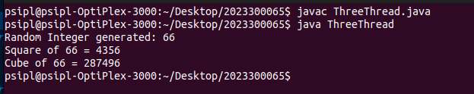

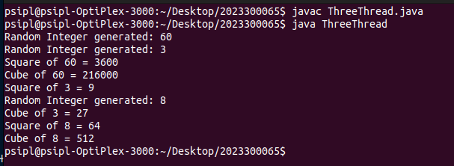
CONCLUSION: | I have learnt about multithreading and use of threads

